INTERNSHIP PROJECT:

ONLINE JOB PORTAL

ABSTRACT:

In this competitive era, the education among the people is so increasing that the jobs for them are now decreasing. The companies even want the people who are best in their fields. At that time, it becomes difficult to find the people who are intelligent enough to be hired. The work for the companies also increases to find the people who can fulfill their requirements. Thinking about these problems, one can think about the process which can handle this process and make the work less complex. This project is about the recruitment process which is done online. The recruitment process here is handled by the system. This project will allow the person to apply for a job in the company for the interested vacancy which would be available at the company. The person will be having the account after registration and will be then called the applied user. If he would be qualified, he would be interacting with the system for the updates. The project is created for fulfilling the requests of the company managers so that the recruitment module can be placed in the company’s website and the users who visit the website can view the vacancies in the company and will be able to apply directly from remote place even. The vacancies will be posted by the administrator on the basis of needs of the manpower in the company. The admin will have all rights of handling this process except the evaluation process as it is the company specific and so the steps of the evaluation process cannot be predicted. It also includes the layers at the admin side so the privileges will have great impact on the functionalities given to the different levels of admin. The privileges will be user specific, so different admin even at same level will have different privileges and so different functionalities. The higher level admin will handle whole system by himself. Although the lower level admin is given such privileges that he can send any kind of request to the higher level admin. The higher level admin can approve or disapprove the request. Whatever the result of the request approval, the notification will be sent to the lower level admin. This project plays main role at admin side for recruitment process. The start dates and end dates for applications’ acceptance, the grace period, the job vacancies’ postings, modifying the privileges etc. are the special features of this system.

OBJECTIVE:

This project is aimed at developing a web-based and central Online job portal for the HR Group for a company. Some features of this system will be creating vacancies, storing Applicants data, Interview process initiation, Scheduling Interviews, Storing Interview results for the applicant and finally Hiring of the applicant.Reports may be required to be generated for the use of HR group.This system automates the manual recruitment process. We believe that once the organization chooses to use this system, it will eventually recognize the value and necessity of this system and understand the problems involved in the manual process. This document provides details about the entire software requirements specification for the online job portal. The project Online Job portal is aimed at developing a web-based and central Recruitment Process System for the HR Group of a company.

INTRODUCTION:

The global economy is disturbed as the new statistics shows. The post-COVID-19 pandemic downturn seems serious as unemployment shall be dominating in and after the calendar year 2021.According to Nasscom, 60% of the major companies have escaped layoffs, but this did not add to employment as these companies retained their original staff. Now, both employers and job-seekers looking for new recruitment and jobs respectively. Perception System addresses the versatile needs of the recruitment industry with the latest trends and features you should consider before job portal development. We recommend you to keep these top features while considering a job portal solution to ensure you derive maximum return on your investment.The recent studies have estimated 18 million resumes doing rounds on various online job portals. The online recruitment market is poised to grow by $3.52 bn in USA during 2020-2024. The stats say that 86% of Organisations are Using Virtual Hiring During COVID-19.Okay, but what are the top list of salient features required for running your Job Board business web portal? Let’s say that if you recognise the functional synopsis below, you would be having good time to consider job portal development with ease.

METHODOLOGY:

This Job Portal System project will help the user to keep the information on the internet, so the access of data becomes easy. The job portal will provide various functions such as managing the vacancies, storing applicant data, maintain the interview time for the applicant and will help to hire the candidates. The Job Portal System will not remove the existing system but will automate most of the parts which are involved in the manual process. The Job Portal System will also help the users to modify the data required by them. This project is able to maintain the data systematically which makes the system effective. Online Job Portal can be really helpful for HR managers as well as job searchers. So, this project is an online job portal site using PHP and MySQL. This project solves many problems of recruiters and job seekers by posting jobs for various positions online .

CODE:

header.php

<!DOCTYPE html>

<html lang="en">

<head>

<meta charset="UTF-8">

<meta http-equiv="X-UA-Compatible" content="IE=edge">

<meta name="viewport" content="width=device-width, initial-scale=1.0">

<link href="https://cdn.jsdelivr.net/npm/bootstrap@5.1.3/dist/css/bootstrap.min.css" rel="stylesheet" integrity="sha384-1BmE4kWBq78iYhFldvKuhfTAU6auU8tT94WrHftjDbrCEXSU1oBoqyl2QvZ6jIW3" crossorigin="anonymous">

<link rel="stylesheet" type="text/css" href="https://stackpath.bootstrapcdn.com/font-awesome/4.7.0/css/font-awesome.min.css">

<title>Dashboard</title>

<style>

.sidebar {

margin: 0;

padding: 0;

width: 200px;

background-color: #f1f1f1;

margin-top:55px;

position: fixed;

height: 100%;

overflow: auto;

}

/* Sidebar links */

.sidebar a {

display: block;

color: black;

padding: 16px;

text-decoration: none;

}

/* Active/current link */

.sidebar a.active {

background-color: #04AA6D;

color: white;

}

/* Links on mouse-over */

.sidebar a:hover:not(.active) {

background-color: #555;

color: white;

}

/* Page content. The value of the margin-left property should match the value of the sidebar's width property */

div.content {

margin-left: 200px;

padding: 1px 16px;

height: 1000px;

}

/* On screens that are less than 700px wide, make the sidebar into a topbar */

@media screen and (max-width: 700px) {

.sidebar {

width: 100%;

height: auto;

position: relative;

}

.sidebar a {float: left;}

div.content {margin-left: 0;}

}

/* On screens that are less than 400px, display the bar vertically, instead of horizontally */

@media screen and (max-width: 400px) {

.sidebar a {

text-align: center;

float: none;

}

}

.navbar {

overflow: hidden;

background-color: #333;

position: fixed; /* Set the navbar to fixed position */

top: 0; /* Position the navbar at the top of the page */

width: 100%; /* Full width */

}

</style>

</head>

<body>

<div>

<nav class="navbar navbar-expand-lg navbar-light bg-light">

<div class="container-fluid">

<a class="navbar-brand" href="#">Admin Dashboard</a>

<button class="navbar-toggler" type="button" data-bs-toggle="collapse" data-bs-target="#navbarNav" aria-controls="navbarNav" aria-expanded="false" aria-label="Toggle navigation">

<span class="navbar-toggler-icon"></span>

</button>

<div class="collapse navbar-collapse" id="navbarNav">

</div>

</div>

</nav>

<div class="sidebar">

<a href="index.php">Job</a>

<a href="jobs.php">Candidates Applied</a>

<a href="contact.php">Contact</a>

<a href="about.php">About</a>

</div>

index.php

<?php include 'header.php'?>

<div class="content">

<p style="padding-top:55px">

<a class="btn btn-primary" data-bs-toggle="collapse" href="#collapseExample" role="button" aria-expanded="false" aria-controls="collapseExample" style="margin-top:10px" >

Post Job

</a>

</p>

<div class="collapse" id="collapseExample">

<div class="card card-body">

<form method="post" action="config.php">

<div class="mb-3">

<label for="Company Name" class="form-label">Company Name</label>

<input type="text" class="form-control" id="" name="cname">

</div>

<div class="mb-3">

<label for="exampleInputPosition" class="form-label">Position</label>

<input type="text" class="form-control" id="exampleInputPosition" name="position">

</div>

<div class="mb-3">

<label for="JobDesc" class="form-label">Job Description</label>

<input type="text" class="form-control" id="JobDesc" name="jdesc">

</div>

<div class="mb-3">

<label for="exampleInputPosition" class="form-label">Skills Required</label>

<input type="text" class="form-control" id="exampleInputSkills" name="skills">

</div>

<div class="mb-3">

<label for="CTC" class="form-label">CTC</label>

<input type="text" class="form-control" id="CTC" name="CTC">

</div>

<button type="submit" class="btn btn-primary" name="post">Submit</button>

</form>

</div>

</div>

<table class="table">

<thead>

<tr>

<th scope="col">#</th>

<th scope="col">Company Name</th>

<th scope="col">Position</th>

<th scope="col">CTC</th>

</tr>

</thead>

<?php

$conn = mysqli_connect('localhost', 'root', '','jobs');

$sql="SELECT `cname`, `pos`,`CTC` FROM `jobs`";

$result=mysqli_query($conn,$sql);

$i=0;

if($result -> num_rows >0){

while($row=$result->fetch_assoc()){

echo "

<tbody>

<tr>

<td>".++$i."</td>

<td>".$row['cname']."</td>

<td>".$row['pos']."</td>

<td>".$row['CTC']."

</tr>";

}

}

else{

echo "";

}

?>

</tbody>

</table>

</div>

</div>

<script src="https://cdn.jsdelivr.net/npm/bootstrap@5.1.3/dist/js/bootstrap.bundle.min.js" integrity="sha384-ka7Sk0Gln4gmtz2MlQnikT1wXgYsOg+OMhuP+IlRH9sENBO0LRn5q+8nbTov4+1p" crossorigin="anonymous"></script>

</body>

</html>

jobs.php

<?php include 'header.php'?>

<div class="content">

<table class="table">

<thead>

<tr>

<th scope="col">#</th>

<th scope="col">Name</th>

<th scope="col">Position</th>

<th scope="col">resume</th>

</tr>

</thead>

<?php

$conn = mysqli_connect('localhost', 'root', '','jobs');

$sql="select name,apply,year from candidates";

$result=mysqli_query($conn,$sql);

$i=0;

if($result->num_rows>0){

while ($rows=$result->fetch_assoc()){

echo'

<tr>

<th scope="row">'.++$i.'</th>

<td>'.$rows['name'].'</td>

<td>'.$rows['apply'].'</td>

<td>'.$rows['year'].'</td>

</tr>';}}

else{

echo"";

}

?>

</table>

</div>

contact.php

<?php include 'header.php'?>

<div class="content">

<div class = "contact" style = "text-align: center;">

<h2>Contact Us</h2>

<div class = "ic">

<a href = "https://api.whatsapp.com/send?phone=+919876543210" target = "_blank"><i style = "padding: 7px; color: grey;" class="fa fa-whatsapp fa-2x" aria-hidden="true"></i></a>

<a href = "tel: +919876543210"><i style = "padding: 7px; color: grey;" class="fa fa-phone fa-2x" aria-hidden="true"></i></a>

<a href = "mailto: abc@def.com"><i style = "padding: 7px; color: grey;" class="fa fa-envelope-o fa-2x" aria-hidden="true"></i></a>

</div>

</div>

<!--<div class = "ctdt">

<h2 style = "text-align: center;">Contact Details</h2>

<p><b>Contact No:</b> +919876543210</p>

<p><b>Mail Id:</b> Jobportalsupportteam@gmail.com</p>

</div>-->

<br>

<div class = "fdbk" style="box-shadow:2px 2px 12px black; margin-left: 20%; margin-right: 20%; padding: 15px;">

<h2 style= "text-align: center;">Feedback</h2>

<form method="post" style = "width : 100%;padding:20px ">

<div class="mb-3" >

<label for="exampleInputEmail1" class="form-label">Email address</label>

<input type="email" class="form-control" id="exampleInputEmail1" aria-describedby="emailHelp" name="cemail">

<div id="emailHelp" class="form-text">We'll never share your email with anyone else.</div>

</div>

<div class="mb-3">

<label for="exampleInputPassword1" class="form-label">Comment</label>

<input type="text" class="form-control" id="exampleInputPassword1" name="comment">

</div>

<button type="submit" class="btn btn-primary" name="contact">Submit</button>

<br>

<?php

$conn=mysqli_connect('localhost','root','','jobs');

if($conn -> connect_error){

die("connection failed:".$conn -> connect_error);

}

echo "";

if(isset($_POST['contact'])){

$sname=$_POST['cemail'];

$com=$_POST['comment'];

$sql = "INSERT INTO `contact`(`email`, `comment`) VALUES ('$sname','$com')";

$rs = mysqli_query($conn,$sql);

if($rs)

{

echo '<script>alert("response received.we will contact you soon..")</script>';

}else{

echo "Error:error occured";

}

}

mysqli_close($conn);

?>

</form>

</div>

</div>

</body>

</html>

about.php

<?php include 'header.php'?>

<div class = "content" >

<div class = "abt" style="margin-top:100px">

<h2 style = "text-align: center; ">ABOUT US</h2>

<p style = "font-size:17px;">Lorem, ipsum dolor sit amet consectetur adipisicing elit. Molestiae harum beatae minus labore sunt nobis vel obcaecati, adipisci aperiam laborum, quisquam nesciunt a, nisi sit omnis ea tempore enim aut.

Lorem ipsum dolor sit amet consectetur adipisicing elit. Porro ducimus, nemo maiores vel dolor, voluptatum unde sequi distinctio veritatis repudiandae adipisci quod fugiat quidem facere inventore voluptatibus harum. Laborum, sapiente!

Lorem ipsum dolor sit amet consectetur adipisicing elit. Perspiciatis impedit consequatur modi quod ipsam distinctio non quas necessitatibus sed! Esse, et eos sed aliquid perspiciatis natus molestias error ipsum dolor.

Lorem ipsum dolor sit amet consectetur adipisicing elit. Perspiciatis impedit consequatur modi quod ipsam distinctio non quas necessitatibus sed! Esse, et eos sed aliquid perspiciatis natus molestias error ipsum dolor.

Lorem ipsum dolor sit amet consectetur adipisicing elit. Perspiciatis impedit consequatur modi quod ipsam distinctio non quas necessitatibus sed! Esse, et eos sed aliquid perspiciatis natus molestias error ipsum dolor.

Lorem ipsum dolor sit amet consectetur adipisicing elit. Perspiciatis impedit consequatur modi quod ipsam distinctio non quas necessitatibus sed! Esse, et eos sed aliquid perspiciatis natus molestias error ipsum dolor

</p>

</div>

</div>

career.php

<!DOCTYPE html>

<html lang="en">

<?php include 'config.php'?>

<head>

<meta charset="UTF-8">

<meta http-equiv="X-UA-Compatible" content="IE=edge">

<link rel="stylesheet" href="https://cdn.jsdelivr.net/npm/bootstrap@4.0.0/dist/css/bootstrap.min.css" integrity="sha384-Gn5384xqQ1aoWXA+058RXPxPg6fy4IWvTNh0E263XmFcJlSAwiGgFAW/dAiS6JXm" crossorigin="anonymous">

<link href="https://cdn.jsdelivr.net/npm/bootstrap@5.1.3/dist/css/bootstrap.min.css" rel="stylesheet" integrity="sha384-1BmE4kWBq78iYhFldvKuhfTAU6auU8tT94WrHftjDbrCEXSU1oBoqyl2QvZ6jIW3" crossorigin="anonymous">

<meta name="viewport" content="width=device-width, initial-scale=1.0">

<title>Career</title>

<style>

.jumbotron-jumbotron-fluid{

background-image: url('nature.jpg');

background-size: cover;

background-attachment:fixed;

width: 100%;

height: 35vh;

}

.jumbotron-jumbotron-fluid .container{

text-align: center;

padding: 20px;

}

.jumbotron-jumbotron-fluid .container h1{

font-weight: 500;

}

.jumbotron-jumbotron-fluid .container p{

font-weight: 500;

}

.row .col-md-4 .jobs{

margin-top: 35px;

margin-left: 15px;

padding: 15px;

border: 1px solid black;

box-shadow: 5px 5px grey;

width: 90%;

height: auto;

}

</style>

</head>

<body>

<div class="jumbotron-jumbotron-fluid">

<div class="container">

<h1 class="display-4"> Job Portal</h1>

<p class="lead">Get best jobs matching your skills.</p>

</div>

</div>

<div class="row">

<?php

$conn = mysqli_connect('localhost', 'root', '','jobs');

$sql = "SELECT cname,pos,Jdesc,skills,CTC from jobs";

$result = mysqli_query($conn,$sql);

if($result->num_rows>0)

{

while($rows = $result->fetch_assoc())

{

echo'

<div class="col-md-4">

<div class="jobs">

<h3 style = "text-align:center;">'.$rows['pos'].'</h3>

<h4 style = "text-align:center;">'.$rows['cname'].'</h4>

<p style = "color: black; text-align: justify;">'.$rows['Jdesc'].'</p>

<p style = "color: black;"><b>Skills Required: </b>'.$rows['skills'].'</p>

<p style = "color: black;"><b>CTC: </b>'.$rows['CTC'].'</p>

<button type="button" class="btn btn-primary" data-bs-toggle="modal" data-bs-target="#exampleModal" aria-expanded="false" data-bs-whatever="@fat">Apply job</button>

</div>

</div>';

}

}

?>

<div class="modal fade" id="exampleModal" tabindex="-1" role="dialog" aria-labelledby="exampleModalLabel" aria-hidden="true">

<div class="modal-dialog" role="document">

<div class="modal-content">

<div class="modal-header">

<h5 class="modal-title" id="exampleModalLabel">Apply for Jobs</h5>

<button type="button" class="close" data-dismiss="modal" aria-label="Close">

<span aria-hidden="true">&times;</span>

</button>

</div>

<div class="modal-body">

<form method="POST">

<div class="mb-3">

<label for="recipient-name" class="col-form-label">Name</label>

<input type="text" class="form-control" name="name">

</div>

<div class="mb-3">

<label for="message-text" class="col-form-label">Applying For</label>

<input type="text" class="form-control" name="apply">

</div>

<div class="mb-3">

<label for="recipient-name" class="col-form-label">Qualification</label>

<input type="text" class="form-control" name="qual">

</div>

<div class="mb-3">

<label for="recipient-name" class="col-form-label">Year Passout</label>

<input type="text" class="form-control" name="year">

</div>

</div>

<div class="modal-footer">

<button type="button" class="btn btn-secondary" data-dismiss="modal">Close</button>

<button type="submit" class="btn btn-primary" name="send">Apply</button>

</form>

</div>

</div>

</div>

</div>

<script src="https://cdn.jsdelivr.net/npm/bootstrap@5.1.3/dist/js/bootstrap.bundle.min.js" integrity="sha384-ka7Sk0Gln4gmtz2MlQnikT1wXgYsOg+OMhuP+IlRH9sENBO0LRn5q+8nbTov4+1p" crossorigin="anonymous"></script>

<script src="https://cdn.jsdelivr.net/npm/@popperjs/core@2.10.2/dist/umd/popper.min.js" integrity="sha384-7+zCNj/IqJ95wo16oMtfsKbZ9ccEh31eOz1HGyDuCQ6wgnyJNSYdrPa03rtR1zdB" crossorigin="anonymous"></script>

<script src="https://cdn.jsdelivr.net/npm/bootstrap@5.1.3/dist/js/bootstrap.min.js" integrity="sha384-QJHtvGhmr9XOIpI6YVutG+2QOK9T+ZnN4kzFN1RtK3zEFEIsxhlmWl5/YESvpZ13" crossorigin="anonymous"></script>

</body>

</html>

login.php

<!DOCTYPE html>

<html lang="en">

<head>

<meta charset="UTF-8">

<meta http-equiv="X-UA-Compatible" content="IE=edge">

<meta name="viewport" content="width=device-width, initial-scale=1.0">

<link href="https://cdn.jsdelivr.net/npm/bootstrap@5.1.3/dist/css/bootstrap.min.css" rel="stylesheet" integrity="sha384-1BmE4kWBq78iYhFldvKuhfTAU6auU8tT94WrHftjDbrCEXSU1oBoqyl2QvZ6jIW3" crossorigin="anonymous">

<style>

body{

background-image:url(nature.jpg);

background-size:cover;

}

.container form{

margin-top:6em;

margin-left:20em;

margin-right:20em;

padding:10px;

background-color:white;

box-shadow:3px 3px 16px black;

}

</style>

<title>Register</title>

</head>

<body>

<div class="container">

<form method="post" action="config.php">

<div class="mb-3">

<label for="exampleInputEmail1" class="form-label">Email address</label>

<input type="email" class="form-control" id="exampleInputEmail1" aria-describedby="emailHelp" name="email">

<div id="emailHelp" class="form-text">We'll never share your email with anyone else.</div>

</div>

<div class="mb-3">

<label for="exampleInputPassword1" class="form-label">Password</label>

<input type="password" class="form-control" id="exampleInputPassword1" name="password">

</div>

<button type="submit" class="btn btn-primary" name="login">Submit</button>

<br>

<p>new user?<a href="register.php">click here</a></p>

</form>

</div>

</body>

</html>

register.php

<!DOCTYPE html>

<html lang="en">

<head>

<meta charset="UTF-8">

<meta http-equiv="X-UA-Compatible" content="IE=edge">

<meta name="viewport" content="width=device-width, initial-scale=1.0">

<link href="https://cdn.jsdelivr.net/npm/bootstrap@5.1.3/dist/css/bootstrap.min.css" rel="stylesheet" integrity="sha384-1BmE4kWBq78iYhFldvKuhfTAU6auU8tT94WrHftjDbrCEXSU1oBoqyl2QvZ6jIW3" crossorigin="anonymous">

<style>

body{

background-image:url(nature.jpg);

background-size:cover;

}

.container form{

margin-top:6em;

margin-left:20em;

margin-right:20em;

padding:10px;

background-color:white;

box-shadow:3px 3px 16px black;

}

</style>

<title>Register</title>

</head>

<body>

<div class="container">

<form method="post" action="config.php">

<div class="mb-3">

<label for="exampleInputName" class="form-label">Full Name</label>

<input type="text" class="form-control" id="exampleInputName" aria-describedby="emailHelp"name="name">

</div>

<div class="mb-3">

<label for="exampleInputEmail1" class="form-label">Email address</label>

<input type="email" class="form-control" id="exampleInputEmail1" aria-describedby="emailHelp" name="email">

<div id="emailHelp" class="form-text">We'll never share your email with anyone else.</div>

</div>

<div class="mb-3">

<label for="exampleInputNumber" class="form-label">Contact Number</label>

<input type="number" class="form-control" id="exampleInputNumber" aria-describedby="emailHelp" name="phone_no">

</div>

<div class="mb-3">

<label for="exampleInputPassword1" class="form-label">Password</label>

<input type="password" class="form-control" id="exampleInputPassword1" name="password">

</div>

<button type="submit" class="btn btn-primary" name="submit">Submit</button>

<br>

<p>Already Registered?<a href="login.php">click here</a></p>

</form>

</div>

</body>

</html>

Config.php

<?php

// database connection code

// $con = mysqli_connect('localhost', 'database_user', 'database_password','database');

$conn = mysqli_connect('localhost', 'root', '','jobs');

if($conn -> connect_error){

die("connection failed:".$conn -> connect_error);

}

echo "";

if(isset($_POST['submit'])){

// get the post records

$name=$_POST['name'];

$email=$_POST['email'];

$number=$_POST['phone_no'];

$password=$_POST['password'];

// database insert SQL code

$sql = "INSERT INTO `users` (`name`, `email`, `phone_no`, `password`) VALUES ('$name', '$email', '$number', '$password')";

// insert in database

$rs = mysqli_query($conn, $sql);

if($rs)

{

echo "Contact Records Inserted";

}else{

echo "Error:could not able to execute $sql. ".mysqli_error($conn);

}

}

session_start();

if(isset($_POST['login'])){

$email=$_POST['email'];

$password=$_POST['password'];

$query="SELECT * FROM `users` WHERE `email`='$email' AND `password`='$password'";

$result=mysqli_query($conn,$query);

$row=mysqli_fetch_array($result,MYSQLI_ASSOC);

IF(mysqli_num_rows($result)==1){

header("location:index.php");

}

else{

$error='emailid or password is incorrect';

}

}

if(isset($_POST['post'])){

$cname=$_POST['cname'];

$position=$_POST['position'];

$description=$_POST['jdesc'];

$skills=$_POST['skills'];

$CTC=$_POST['CTC'];

$sqli="INSERT INTO `jobs`(`cname`, `pos`, `jdesc`, `skills`, `CTC`) VALUES ('$cname','$position','$description','$skills','$CTC')";

$rd = mysqli_query($conn, $sqli);

if($rd)

{

header("location:index.php");

}else{

echo "Error:could not post $sql. ".mysqli_error($conn);

}

}

if(isset($_POST['send'])){

$name=$_POST['name'];

$apply=$_POST['apply'];

$qual=$_POST['qual'];

$year=$_POST['year'];

$sqlii="INSERT INTO `candidates`(`name`, `apply`, `qual`, `year`) VALUES ('$name','$apply','$qual','$year')";

$s=mysqli_query($conn,$sqlii);

}

mysqli_close($conn);

?>

RESULTS AND OUTPUT:

Index.php

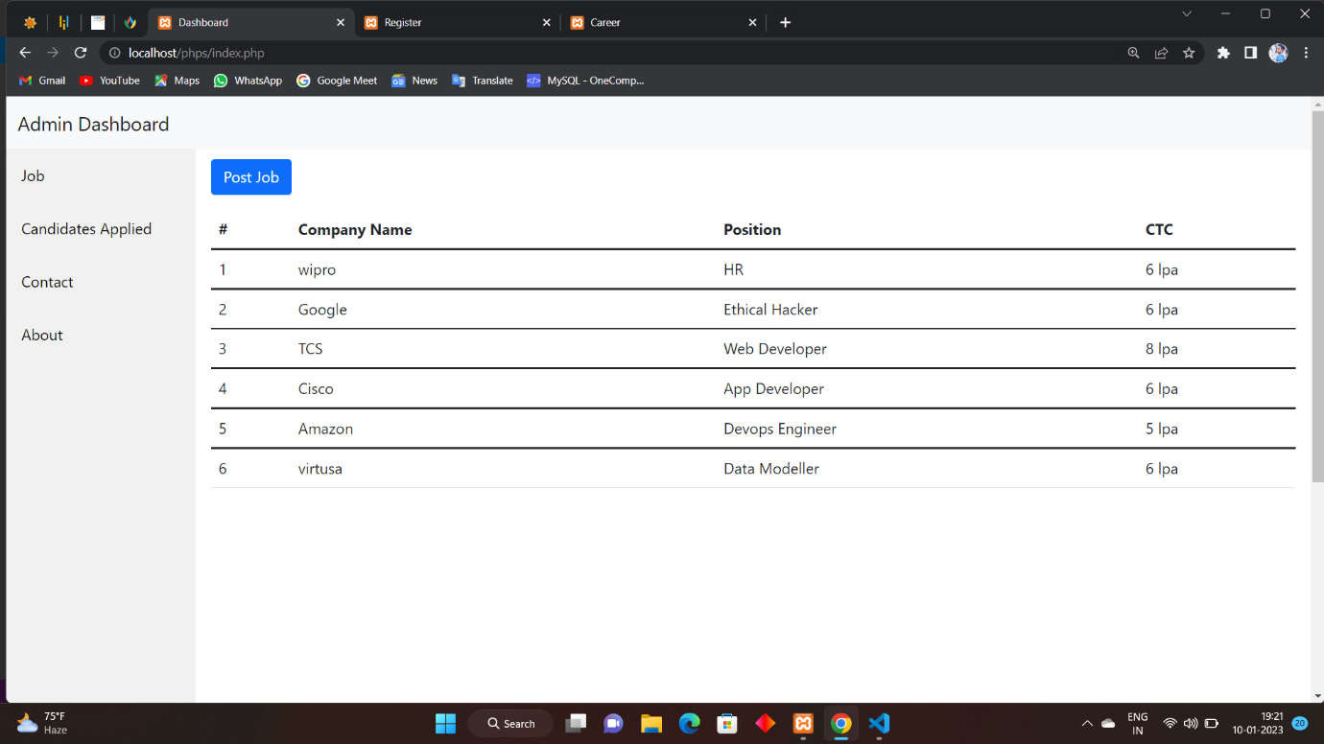

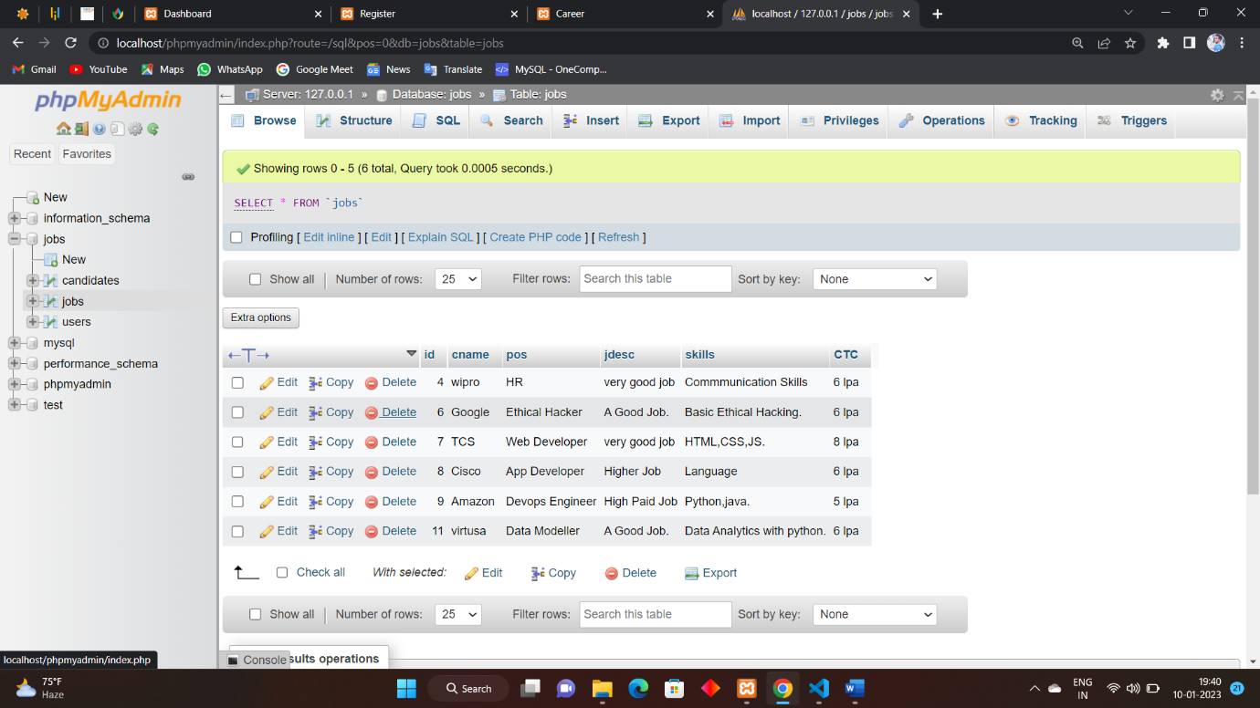

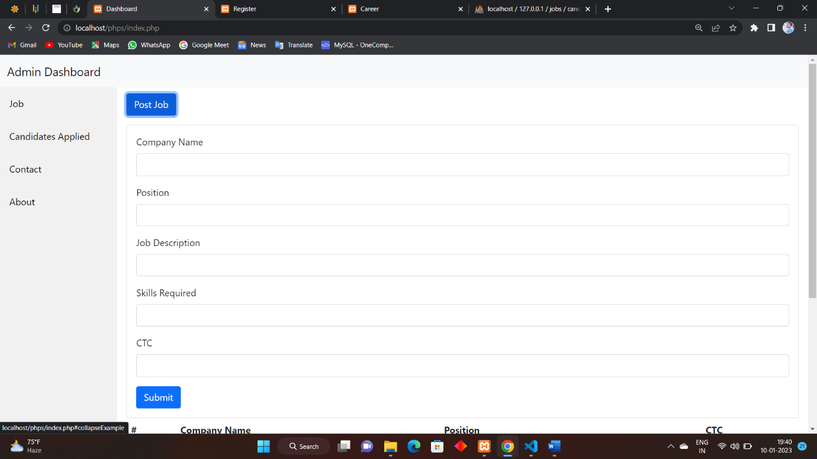

Jobs.php

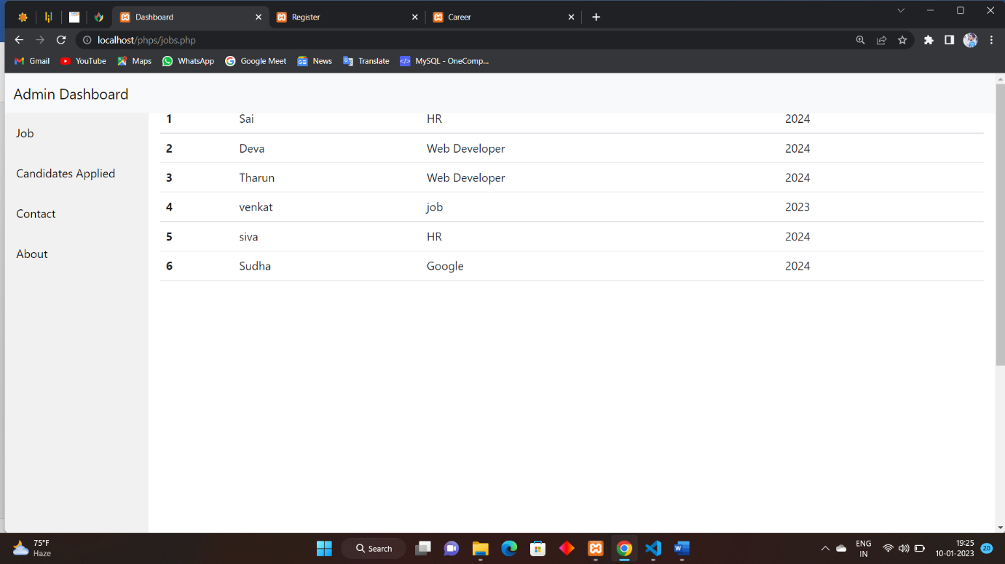

Contact.php

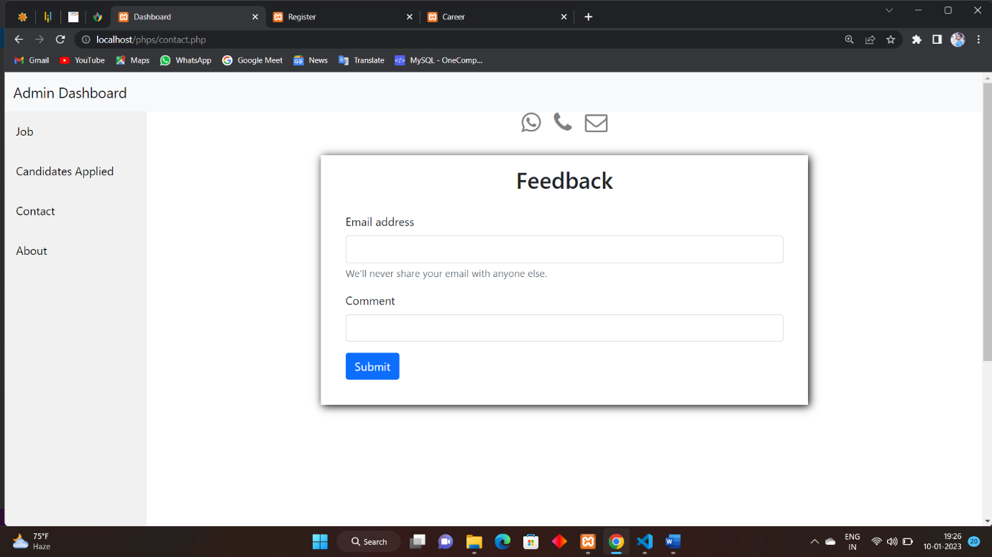

About.php

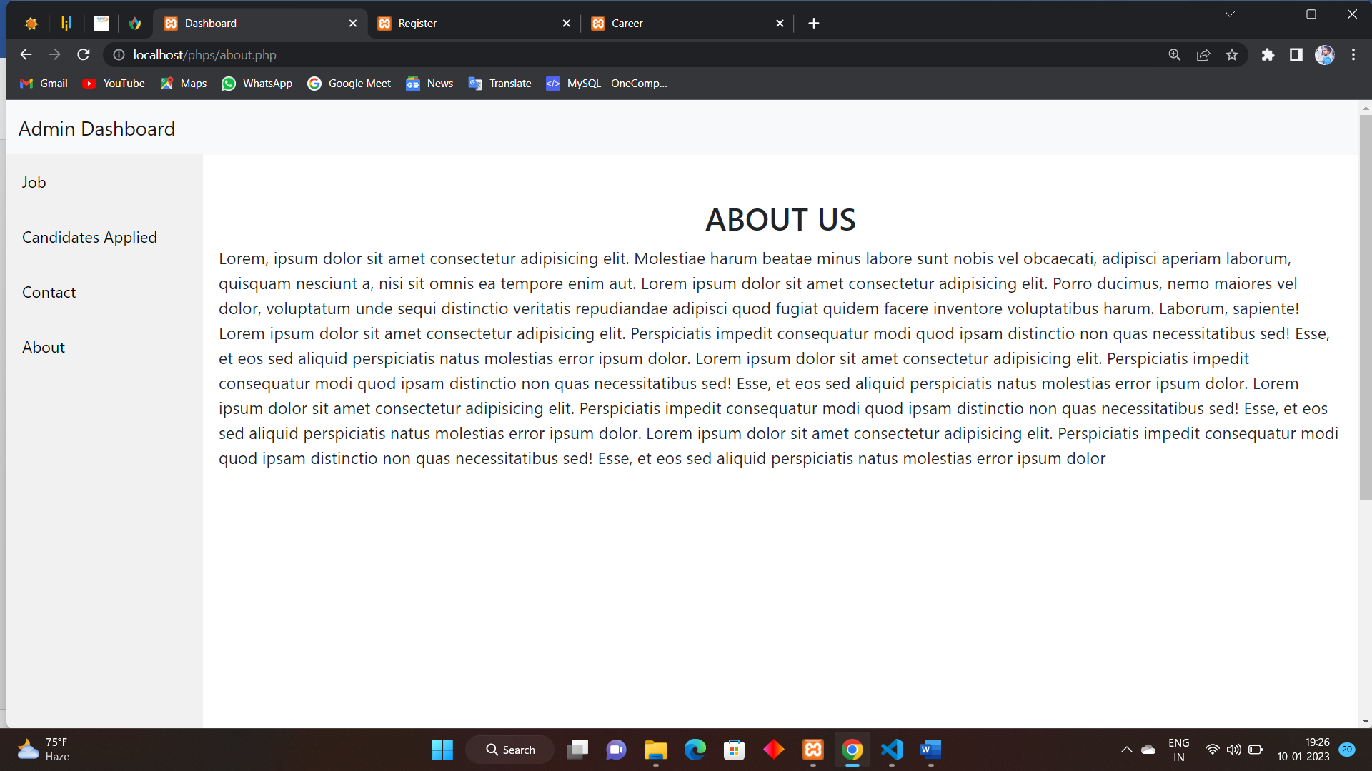

Career.php

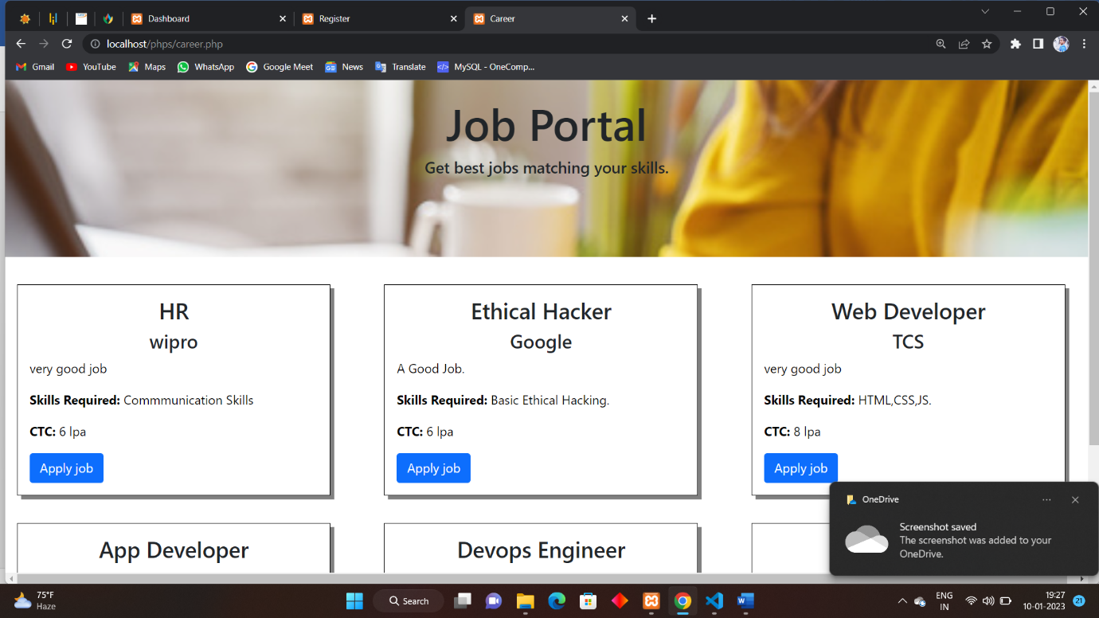p

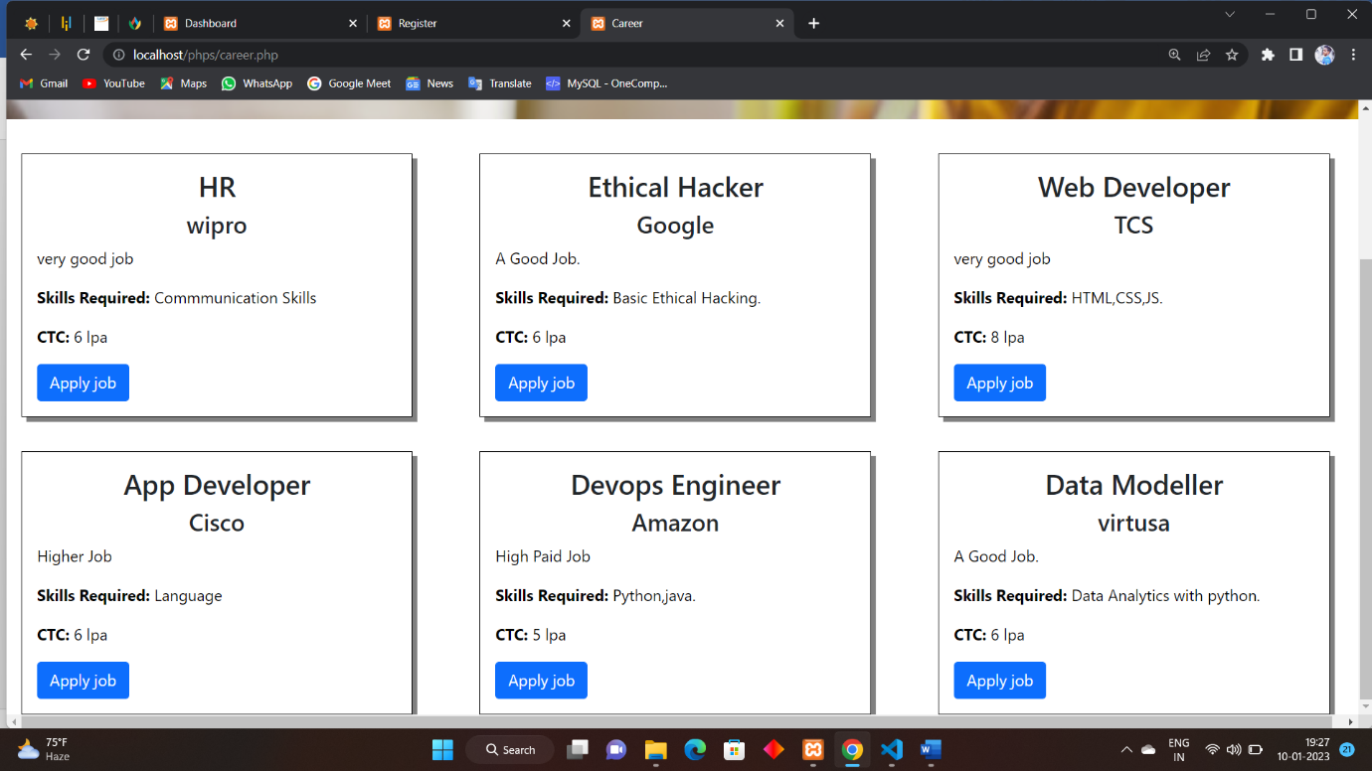

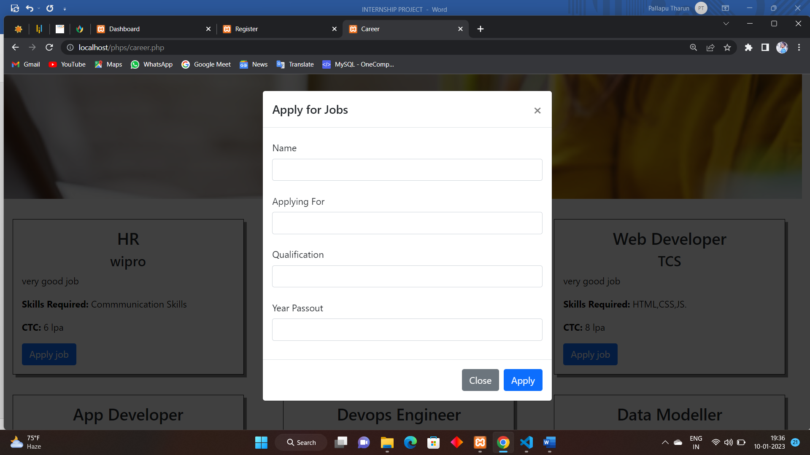

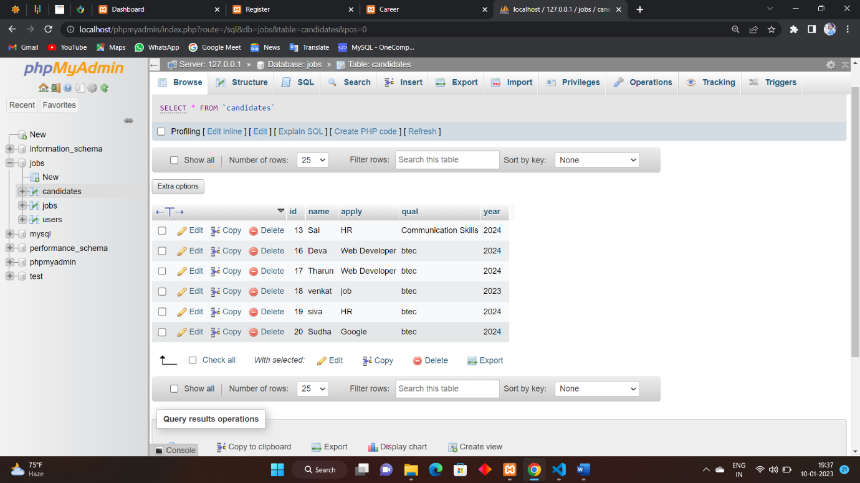

login.php

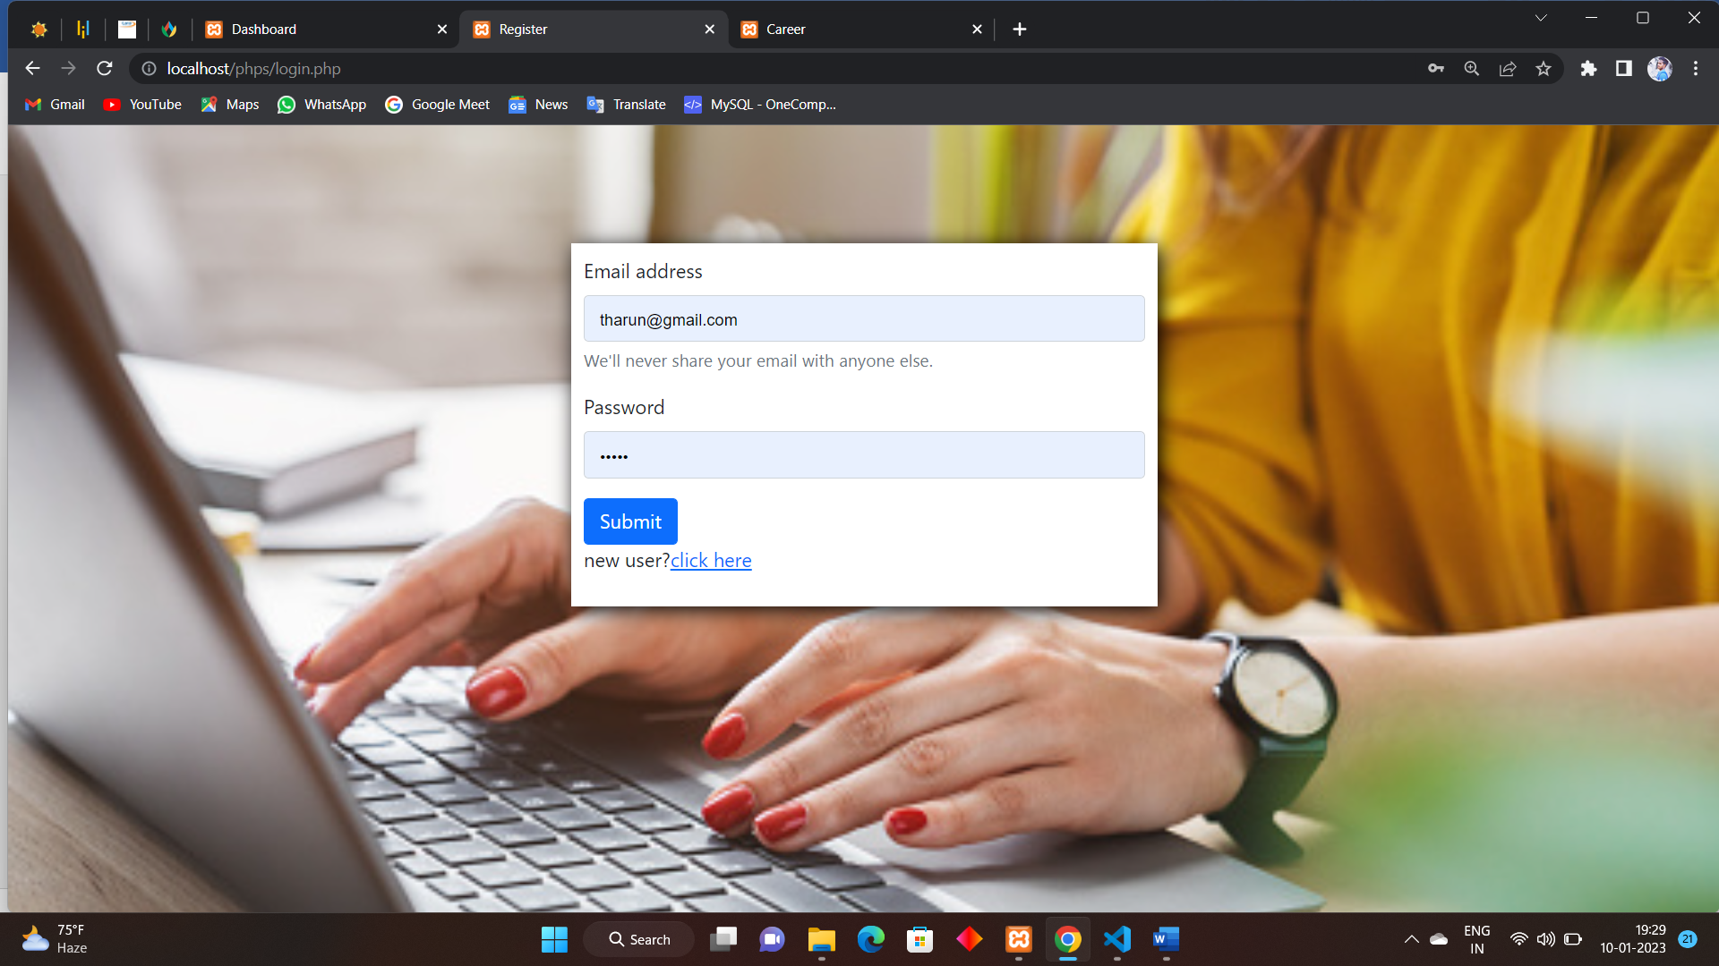

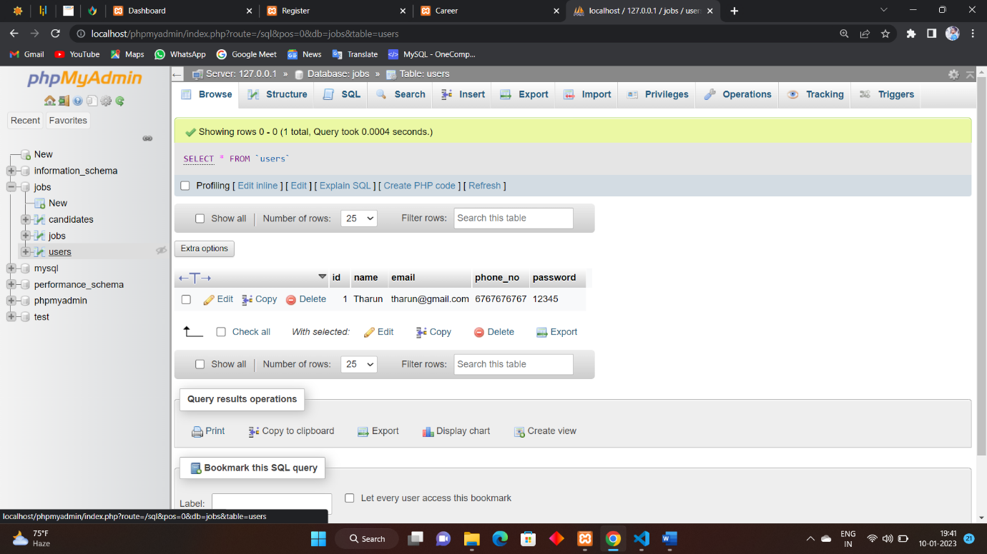

Register.php

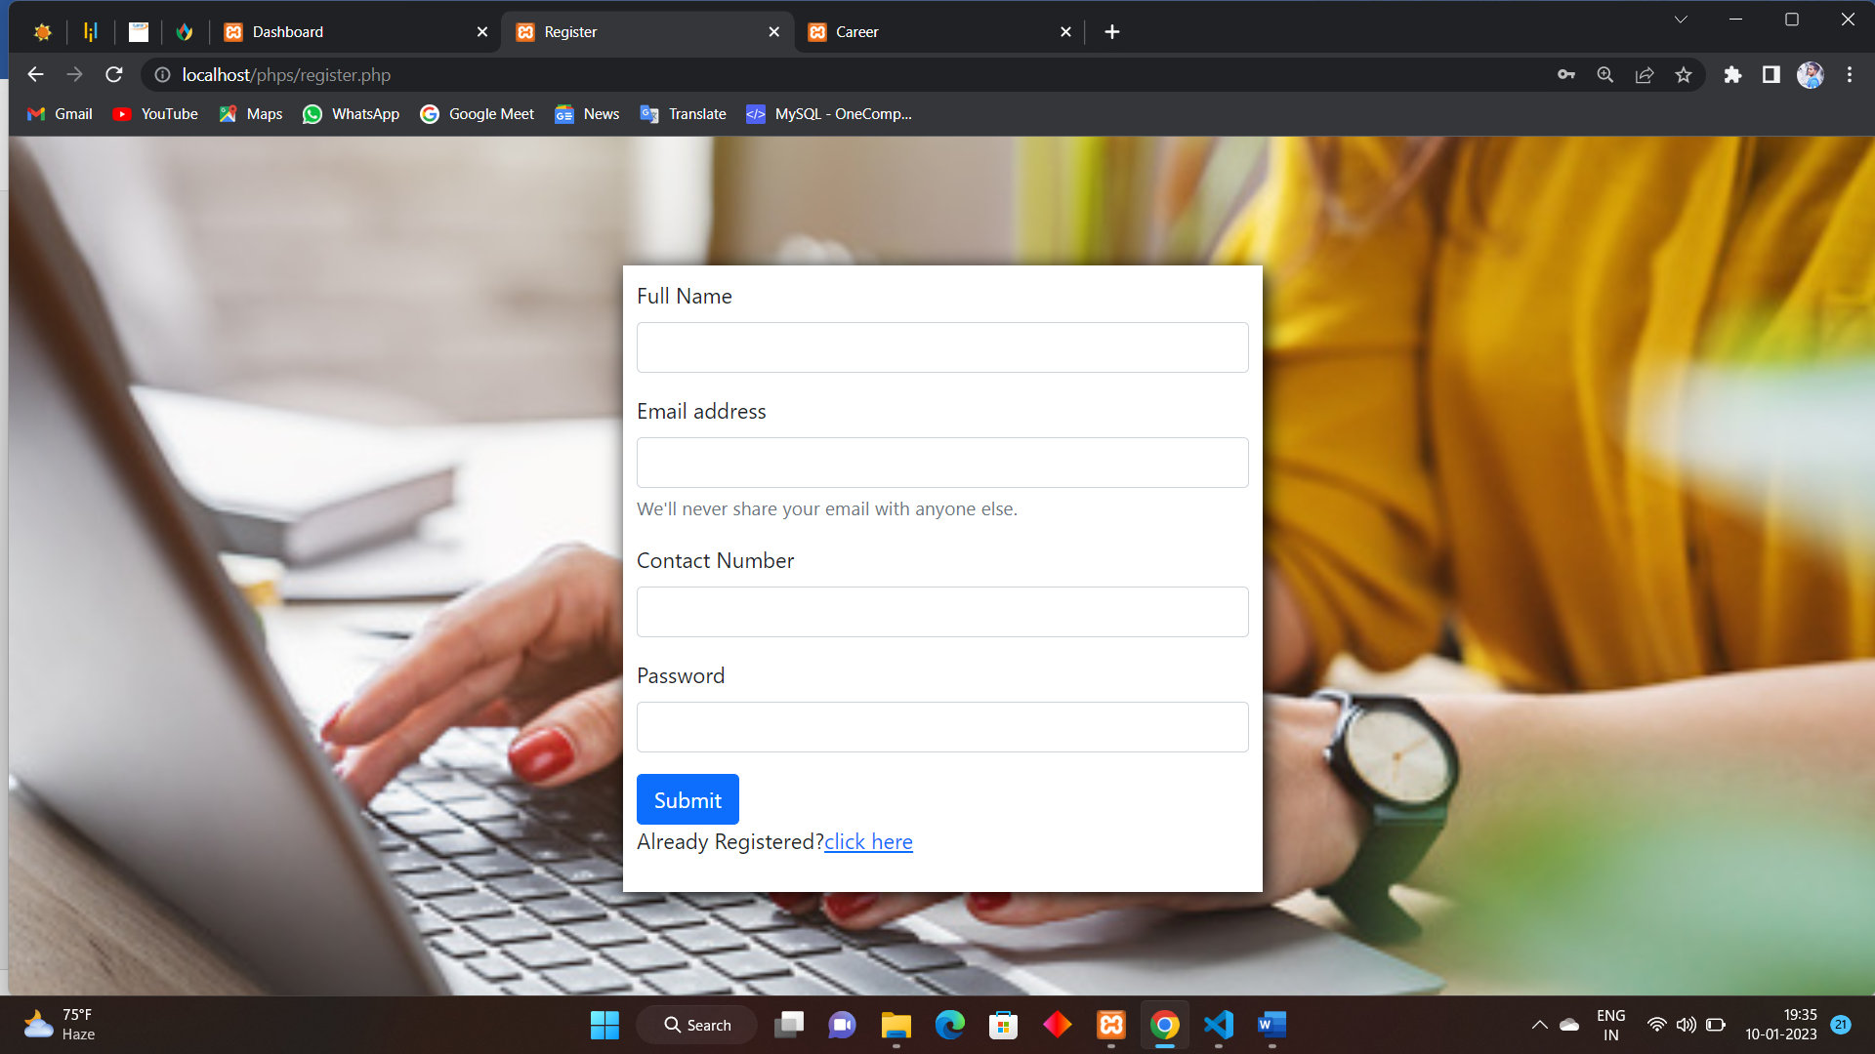

CONCLUSION:

The job portal web page is useful for both companies as who are willing to give the jobs and for the persons who are searching for j